Contents

Set up the project 2

Layer groups 2

Lookup tables 2

TMP group 2

Monitoring Spatial Tables 3

Protocol A 3

Protocols B, C, D and E 4

Model Tools 4

01 Create Sample Zone 7

02 Find Sample Plot 11

03 Target Status 13

04 Back Ground Stratus 14

Create Random Quadrats 14

PA Monitoring Model

This document is intended as an introductory guide on how to set up and use the QGIS monitoring model template.

# Changelog:

V1.0.0 from 20220523: First release

V1.0.1 from 20220726:

* Quadrat column renamed in photo protocol
* Columns from photo protocol align with metadata from Niall
* Plot ID removed from every protocol (redundant)
* CB updated veg naming
* Bare ground, bare rock, water, litter, etc added to veg sp list
* NULL by default on presence absence
* Coverage for protocol C moved after presence/absence
* Field NOTES added to quadrat info
* Browsing categories updated to have percentages
* Sliders removed
* Coverage percentages to be drop down menu

V1.0.2 from 20220805:

* Remove protocol D
* Remove trampling
* Ditch blocking to add NA to water speed
* Remove categories for percentages
* Add constraint for percentage in protocol C
* Review fid column as Qfield is creating a duplicate of the fid column called (fid_1). This does not have an impact but is annoying.
* Remove slidebar for the height.
* On Microtopography need to add TK.

# Set up the project

## Layer groups

Layer groups aim to keep the table organised. Feel free to modify the groups at your choice. The proposed schema is defined below.

### Lookup tables

There is no need to interact with these tables unless you want to add any missing category. For example, if a vegetation species is missed from the list, you can add them manually on the table lu_vegetation_species.

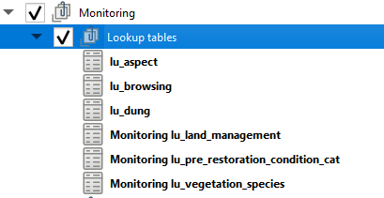

### TMP group

Use the tmp layers group to create temporary layers. When running a model, then make sure this group is selected, so all the outputs will be generated here. Temporary layers will have a scratch symbol, so it is easy to recognise them and delete them after they are imported into the monitoring spatial table.

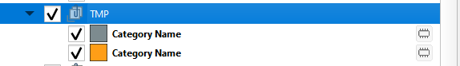

### Monitoring Spatial Tables

Tables in this group are manually imported by the user after running the tools.

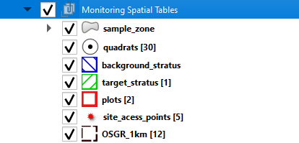

For example:

* The sample zone table will contain the layers generated after running the model “01 Create Sampling Zone” by pre restoration category.
* The plots table will contain plots generated after the user manually copy the results from “02 Find Sample Plot”.
* Background stratus and target stratus will be manually copied from the temporary outputs created after running the models 03 Target stratus and 04 Background stratus.
* OSGR 1km will contain the OSGR from the plugin OSGR tool. The 1km grid reference is needed to run the first model. You will need to import it from the plugin.
* Site access points will be generated by the user using the satellite imagery.

### Protocol A

Once you have created all your restoration lines and polygons using the PA template, then load the layers in the geopackage from the PA template to the Protocol A group.

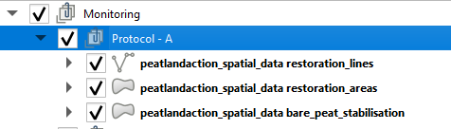

The layers on the protocol A will be used as inputs for most of the workflow.

### Protocols B, C, D and E

These protocols will contain tables with no spatial dimensions. Although they will be relationed to the quadrats ID.

## Model Tools

There are 4 model tools that have been created for this specific monitoring template. They will behave as any other QGIS Algorithm. Run them in order to get the plots per pre-restoration category.

The first time you use them, you will need to load the models into your QGIS template. This is a one time task. Then, the models will be available in any QGIS workbench you open on your computer. Please note that the models will only work on QGIS 3.16 and above.

To load the models, open the processing toolbox, then click on Add Model to Toolbox and load them one by one from your local computer.

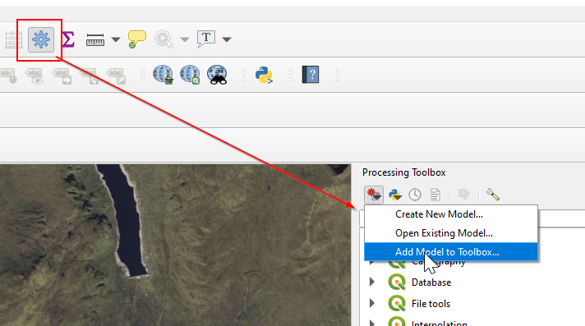

Once you have loaded all the models, they will show up at the bottom of your Processing toolbox.

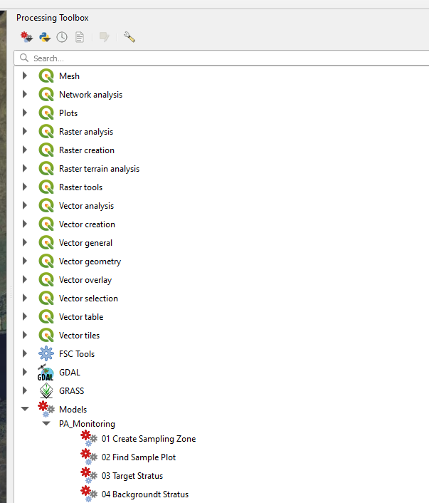

## 

# 01 Create Sample Zone

Open attribute table and build a expression to select your restoration features:

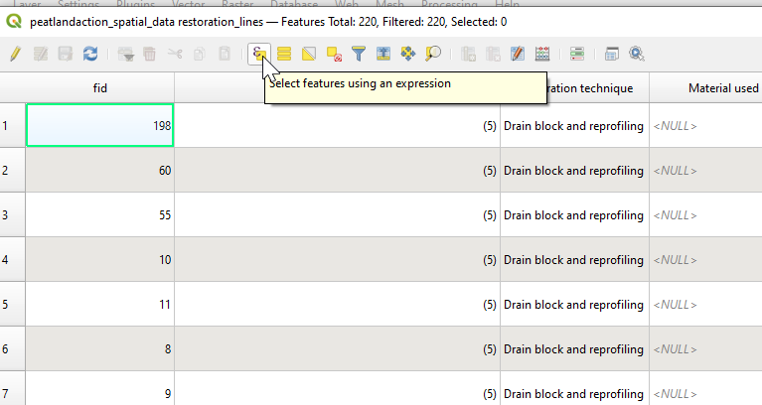

Open fields and Values

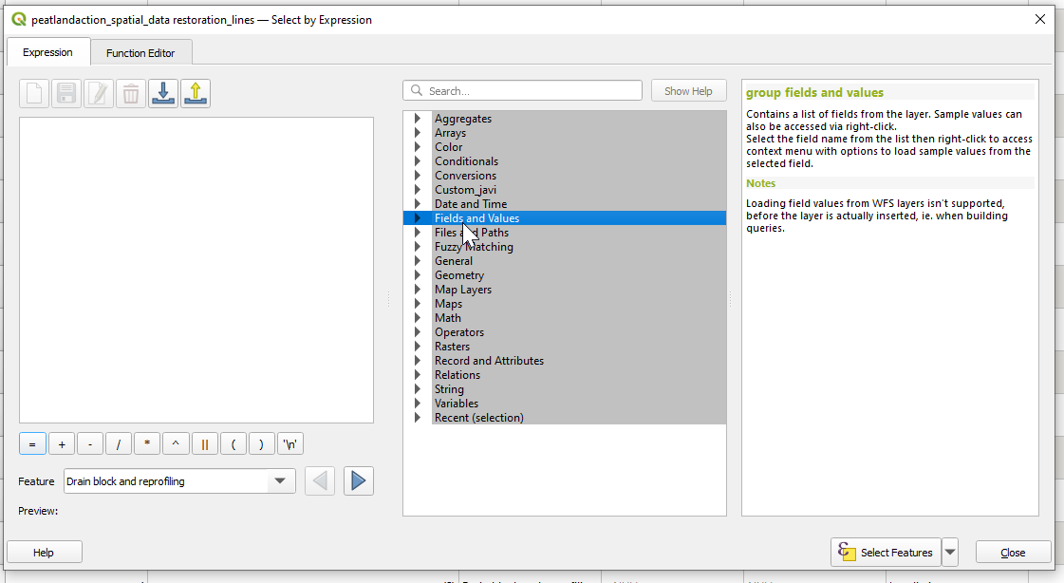

Double Click on Restoration Techniques, then “All Uniques” to see unique techniques.

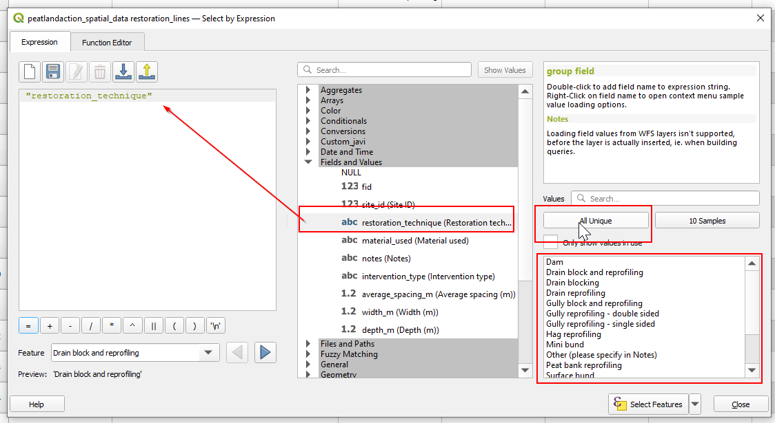

Now, within the expression window, you can select your “restoration techniques”. Be aware of the syntax, you will need to use a single quotation for each technique, separate each technique by comma and write all of them within a parenthesis.

For example, for the restoration lines in Actively eroding blanking bog, you will need to use the next syntax:

*"restoration_technique" in ( 'Gully reprofiling - single sided', 'Gully reprofiling - double sided', 'Hag reprofiling', 'Trench bund', 'Surface bund', 'Mini bund', 'Gully block and reprofiling' )*

Click on select features and move to the next feature (Area base restoration and/or Bare Peat Stabilisation).

Look at the ANNEX I for some other filters.

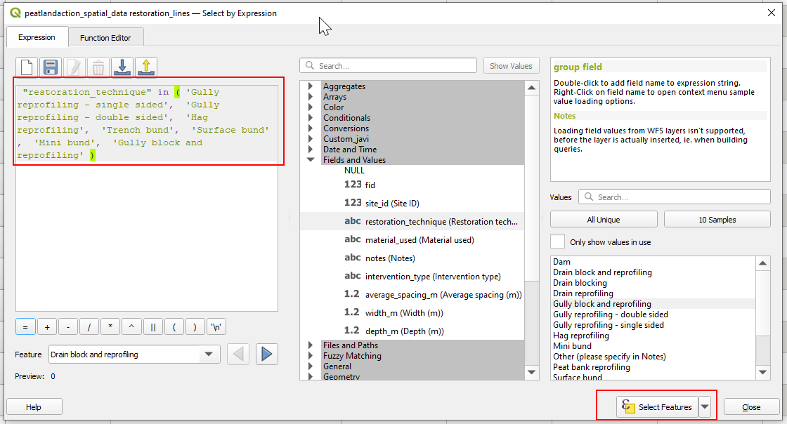

If you wish to select all features for one table, then open the attribute table and press “Ctrl + A). Close the attribute table.

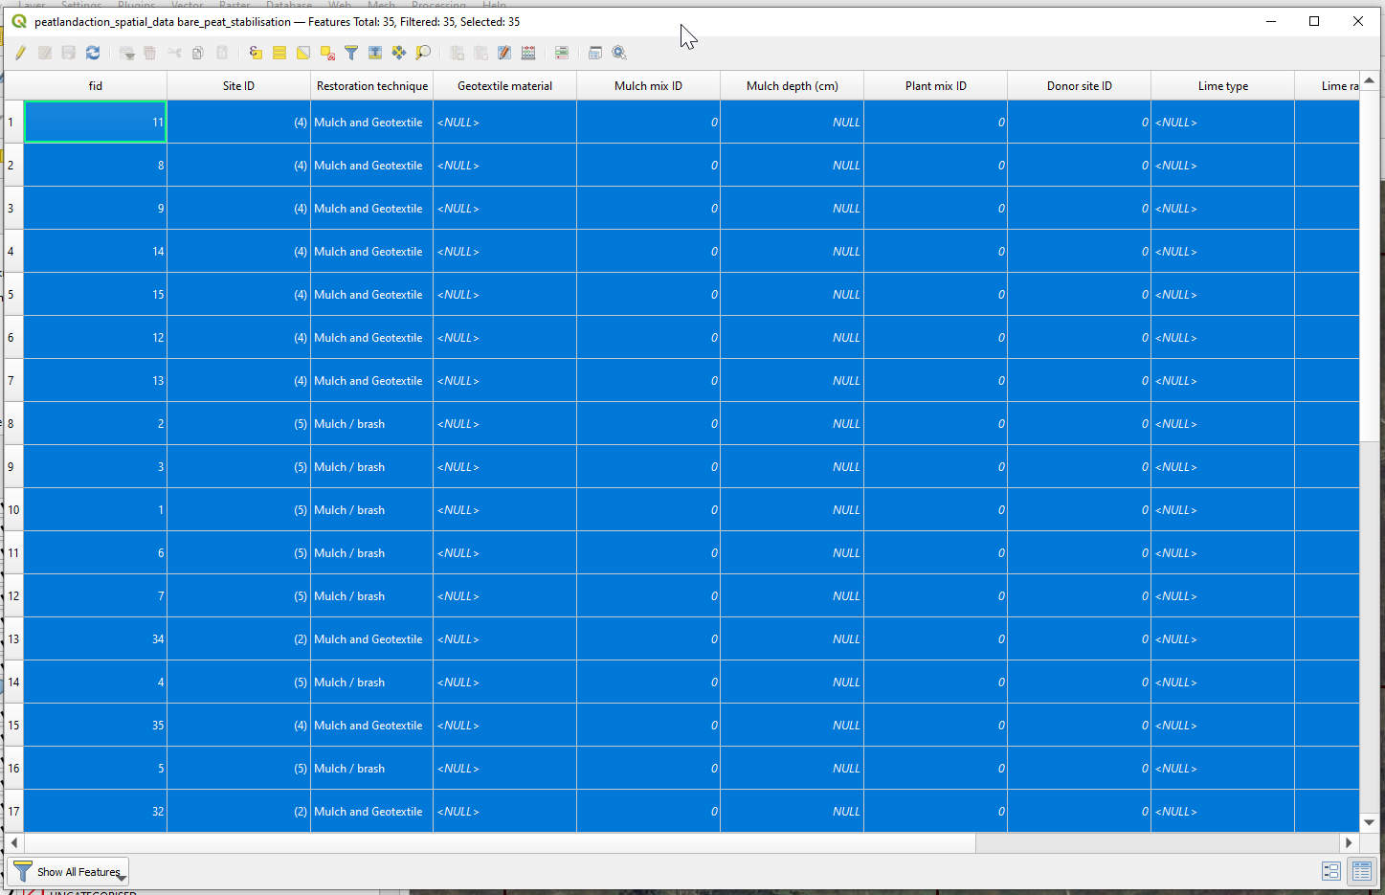

Run the Model for Creating Sampling Zones. The model will run using JUST the selected features from your inputs.

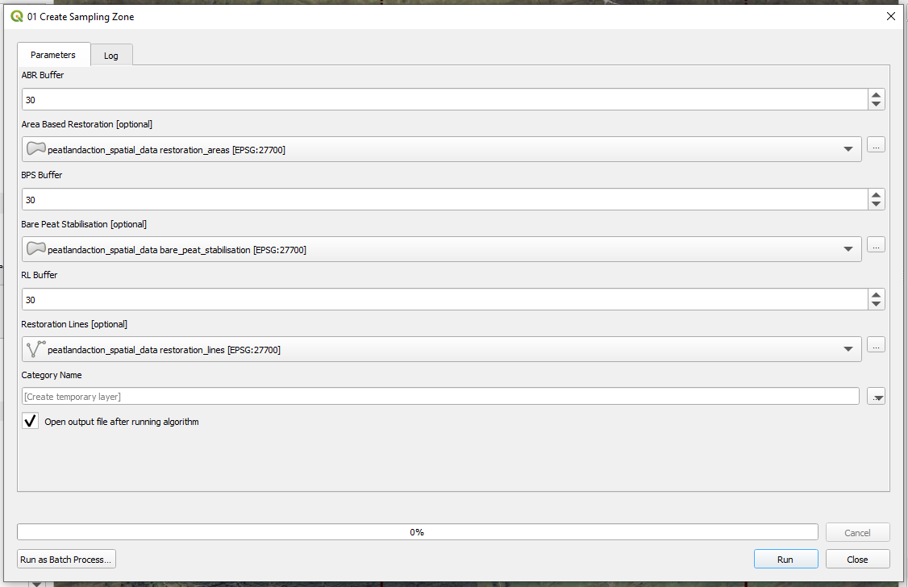

The output will be a temporary layer. Open the attribute table of the output layer, select the features, click on “copy”:

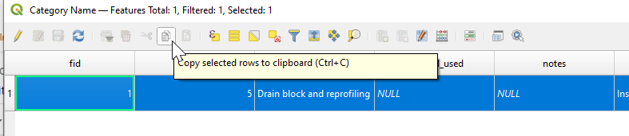

Then go to the Sample Zone layer on the geopackage, open the attribute table and paste the features on it:

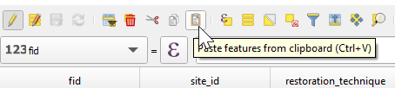

A new window will pop-up. Make sure you type an unique ID number and you select the category.

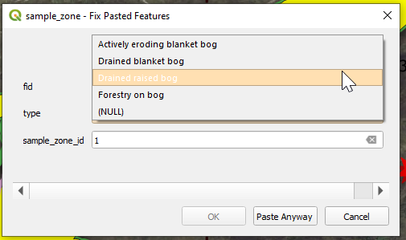

Now, unselect all features in your QGIS template  and move onto the next category.

**NOTE**: If one of the sampling zones does not have any restoration feature, you will still need to select it in the input files. For example, drained blanked bog do not have Bare Peat Stabilisation features, but if we don't select the table as input, the tool will crash:

# 02 Find Sample Plot

This tool aims to be used per Sample Zone. It will find out 1 sample plot based on user defined parameters.

Main Parameters:

* Input layers:
  + Sample Zone layer where at least 1 category has been selected.
  + Site access points
* Vertical Horizontal Shift: By default it will be 0 metres.
* Vertical Horizontal plot size: By default it will be 500 metres.
  + If the user changes the horizontal and vertical plot size, then she/he will need to modify the formula that calculates the percentage of restoration surface within a 25ha plot.
  + Example 1: 500 by 500 metres plot (25ha)

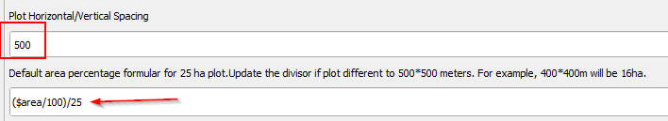

* + Example 2: 400 by 400 metres plot (16ha)

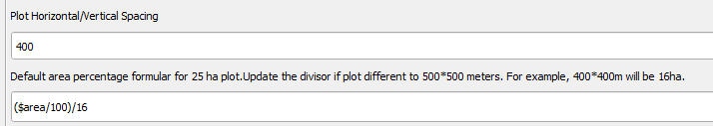

* Site access distance: By default 1000 metres.
* Percentage of area restored within 25ha plot (500*500m). By default it is a minimum of 60%. User can modify this value (see screenshot below)



To run the model, make sure you have selected 1 category from the sample zone table. The final plot will be on the temporary table called “04 Random Selection Bigger than“

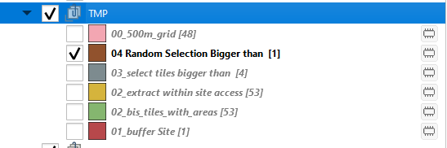

Open the attribute table and copy it content to the the plots table on the monitoring spatial table. Key values like the pre restoration category and the sample zone ID will be automatically copied into the plots table.

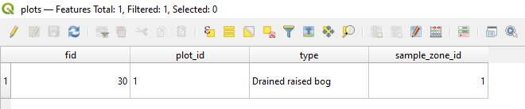

When pasting a second plot, (for example, after running the model again on a different pre restoration category) your ID’s should match for the sample_zone_id and in the case of the plot_id, the ID should auto increment by one.

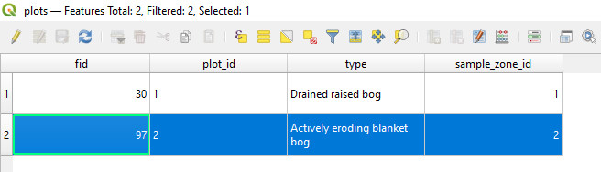

# 03 Target Status

As a suggestion, the model called “03 Target Stratus” creates a target stratus polygon as a dissolved polygon from restoration lines and polygons. The lines are buffered by default value of 10 centimetres (user can change it), so the polygon derived from the lines is effectively a 20cm wide line.

This will help the user to find out random quadrats across the entire target stratus (which is originally derived from two different types of geometries, lines and polygons).

**NOTE: The same tool is also exporting (clipped to the plot boundary) the restoration lines and polygons, in case the user prefers to use the raw clipped features to find out the random quadrats.**

To run the model, make sure you have 1 plot selected from the plots table. The output will be a dissolved polygon like the one shown below:

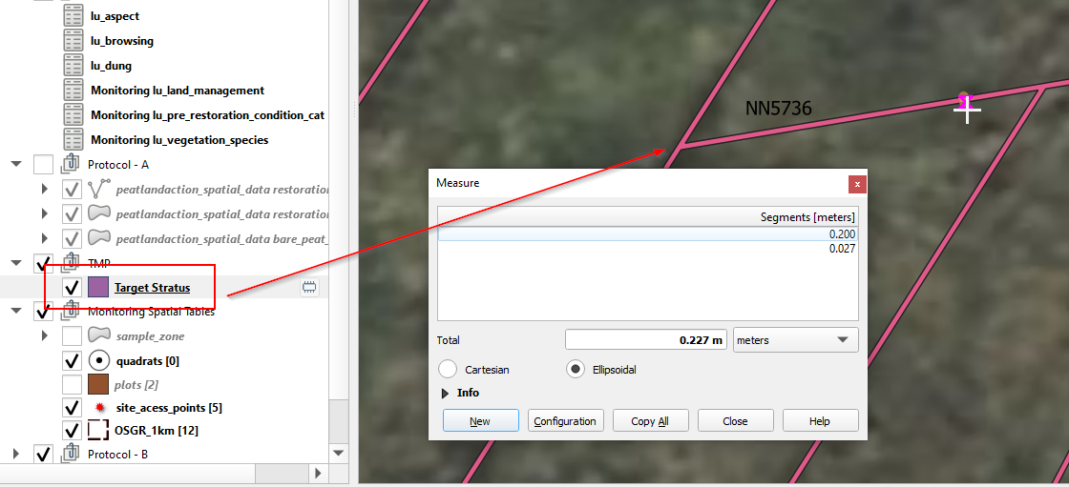

Copy the temporary target stratus table into the monitoring spatial data group layer. All the ID’s and the pre restoration category will be added:

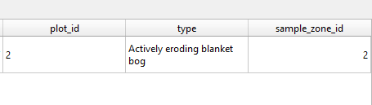

# 04 Back Ground Stratus

Same approach as Target stratus. The user can select buffer to exclude restoration features. By default it will be 1.5 meters each side for lines and 0 meters buffer for restoratiron polygons.

Once the table is created, safe all relevant features within the

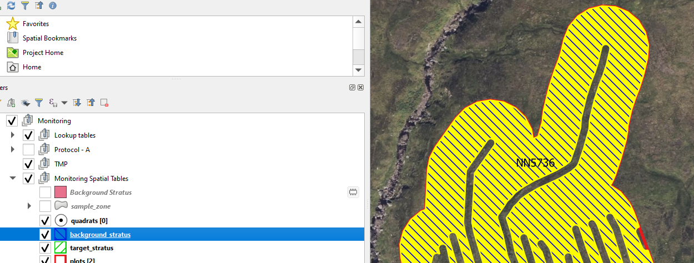

# Create Random Quadrats

To create the random quadrats for each stratus, you can use the tool called “random points in polygon” from QGIS. Just make sure you have selected the stratus before running the tool.

For the target stratus, where the lines were buffered to convert them to polygons, the random quadrats will be something like this:

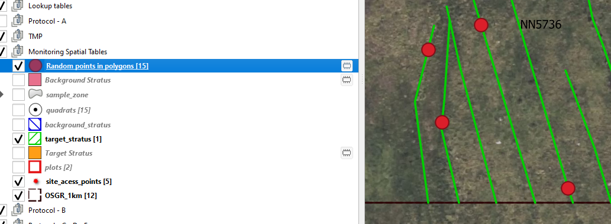

Once the quadrats are generated and you are happy with them, copy the quadrats into the quadrats table on the monitoring spatial table group. Fields like the plot ID, stratus ID, and so on, should be automatically populated. You will need to update the stratus type on the table.

**To generate the quadrat IDs, run the python script:**

* Open the Python Console:

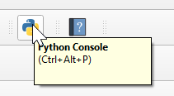

* Click on Show Editor:

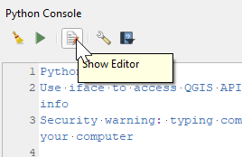

* Open the script called “update_quadrat_id” by loading it from your local machine:

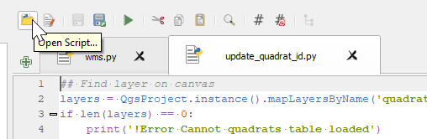

* Run it:

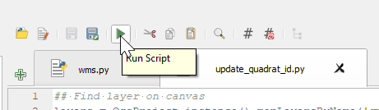

* The ID’s will be then generated:

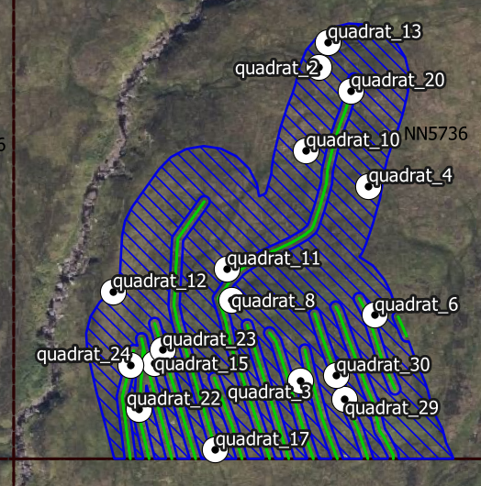

To edit the quadrat data, and all the related protocols to the quadrat, start the editing mode on the quadrats table and then use the identify features tool in QGIS:

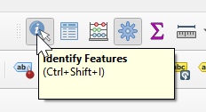

Click on one quadrat and then click on “view feature forms”, the quadrat table will pop-up in editing mode with all linked protocols. Enjoy it!

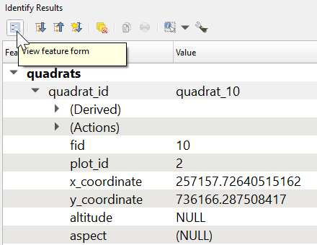

**ANNEX I: Filters**

For Actively Eroding:

Lines:

*"restoration_technique" in ( 'Gully reprofiling - single sided', 'Gully reprofiling - double sided', 'Hag reprofiling', 'Trench bund', 'Surface bund', 'Mini bund', 'Gully block and reprofiling' )*

Bare Peat Stabilisation: All types (Open attribute table and then Cntrl + A)

Area Based Restoration:

*"restoration_technique" in ( 'Trench bund', 'Surface bund', 'Cell bund', 'Gully bund / dams', 'Micro erosion repair', 'Gully reprofiling', 'Hag reprofiling', 'Gully block and reprofiling')*

For Drained Blanked Bog:

Lines:

*"restoration_technique" in ( 'Dam', 'Drain blocking', 'Wave dam', 'Wave dam and reprofiling', 'Drain block and reprofiling', 'Drain reprofiling')*

Area based restoration:

*"restoration_technique" in ( 'Trench bund', 'Surface bund', 'Cell bund', 'Drain blocking and reprofiling' )*